**Lab Practical #05:**

Study the concept of VLAN using packet tracer.

**Practical Assignment #05:**

1. **Implement the different network structures in VLAN and VLAN trunking. Also check connectivity between them using ping command or PDU utility.**

**Instructions:**

1. Different VLANs configuration setup screenshot. (VLAN example given by lab faculty)
2. Write steps to create VLANs in packet tracer.
3. Mention IP address of each pc as label.
4. Ping command or PDU screenshot between two VLANs.

**Step 1: Add Devices**

* Drag **1 switch** and **8 PCs** from device list.
* Connect PCs to the switch using **Copper Straight-Through cables**.

**Step 2: Assign IP Addresses to PCs**

* Click on **PC → Desktop → IP Configuration**.
  + PC1: 192.168.1.2 / 255.255.255.0
  + PC2: 192.168.1.3 / 255.255.255.0

…

* + PC3: 192.168.1.6 / 255.255.255.0
  + PC4: 192.168.1.7 / 255.255.255.0

…

(PC1 to PC4 belong to VLAN 10, PC4 to PC5 to VLAN 20).

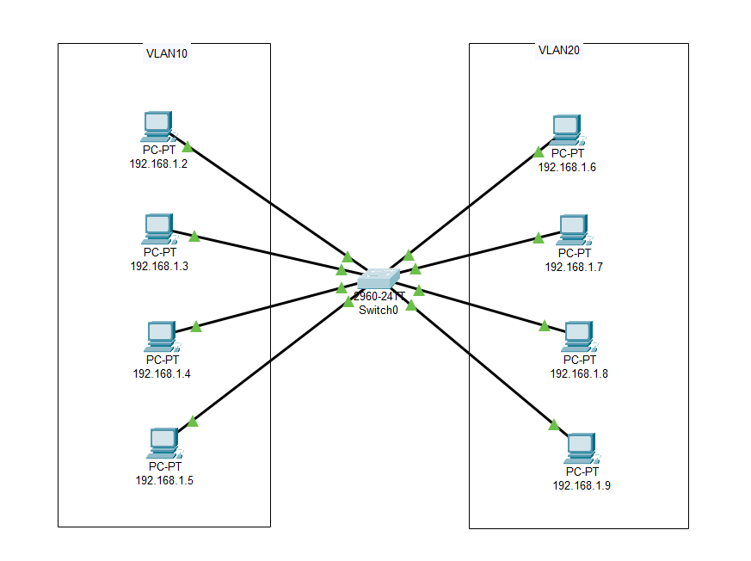

**Step 3: Open Switch VLAN Settings**

1. Click on the **Switch → Config tab**.
2. In **VLAN Database**, you will see default VLANs.
3. Click **Add** →
   * VLAN ID: 10, Name: VLAN10
   * VLAN ID: 20, Name: VLAN20

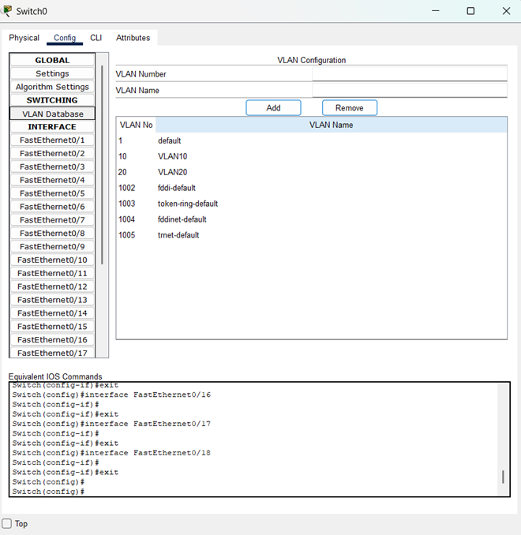

**Step 4: Assign VLANs to Ports**

1. Still in **Switch → Config tab** → select **FastEthernet port**.
2. Example:
   * For **Fa0/1** (PC1) to **Fa0/4** (PC4) → set **VLAN: 10**.
   * For **Fa0/5** (PC5) to **Fa0/8** (PC8) → set **VLAN: 20**.

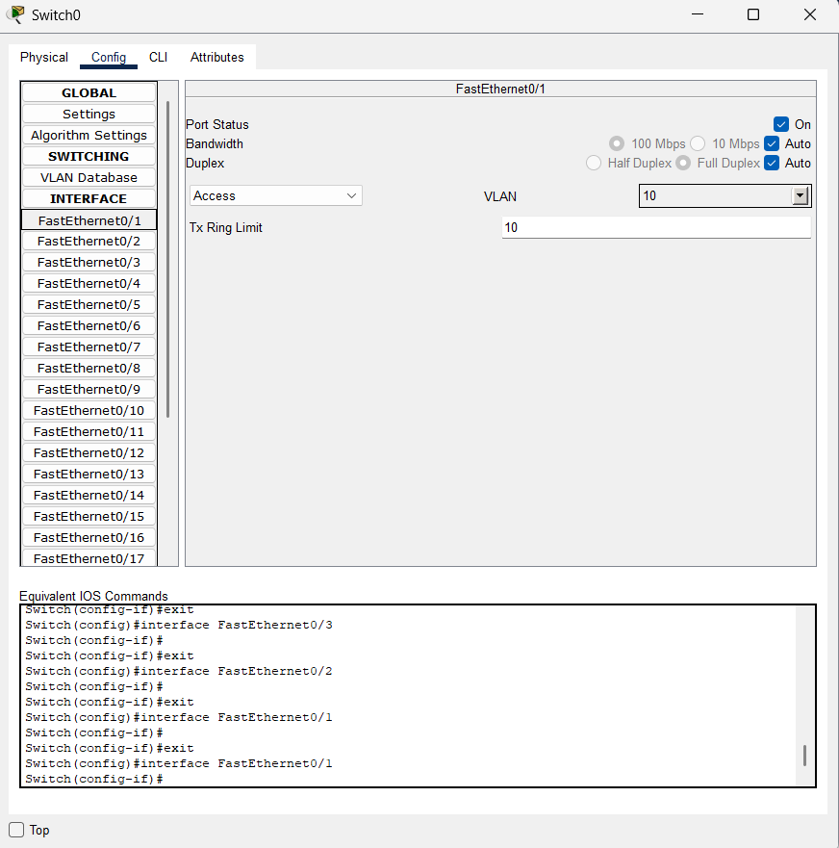

**Step 5: Test VLAN Communication(Two Ways)**

**First Way**

* Go to **PC1 → Command Prompt →** ping 192.168.10.3 ✅ Success.
* Try ping 192.168.20.2 ❌ Fail (different VLANs).

**Second Way**

**Step 1: Send a Packet**

1. Click on **“Add Simple PDU**” (envelope icon) from the right toolbar**.**
2. Click **source PC** (e.g., PC1).
3. Then click **destination PC** (e.g., PC2)**.**

**Step 2: Switch to Simulation Mode**

* In Packet Tracer, at the bottom-right, switch from **Realtime** to **Simulation** mode**.**

**Step 3: Observe the Result**

* If both PCs are in the **same VLAN** (e.g. PC1 → PC2 in VLAN 10)**:  
  ✅** Packet will travel **successfully** and show green check**.**

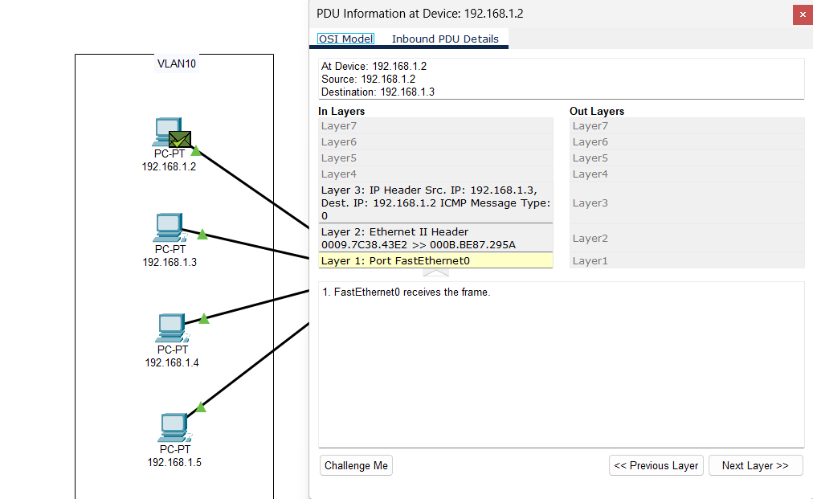

* If PCs are in **different VLANs** (e.g. PC1 → PC3, VLAN 10 → VLAN 20)**:  
  ❌** Packet will be dropped, showing **red** **cross.**

